|  |  |  |  |  |  |
| --- | --- | --- | --- | --- | --- |
| Date | 6-Dec-22 | | | Tester Name | Mayuri Patel |
| Environment | Penfax - Test | | | Login used |  |
| Operating System | Select OS | Version: | Update: | | |
| Software Used | Select Software | Version: | Update: | | |
| Select Software | Version: | Update: | | |
| Release version | 22.4.1 | | | | |
| Title |  | | | | |
| Test Type | Regression | | | | |
| Test Scenario | Process death payment to non-spouse beneficiary | | | | |
|  |  | | | | |
| Expected Results |  | | | | |
| Pass/Fail | Pass | | | JIRA# | N/A |

Describe your steps with screenshots:

Search for a deferred survivor VPB active member who has non-spouse as primary VPB beneficiary

Open that member Profile

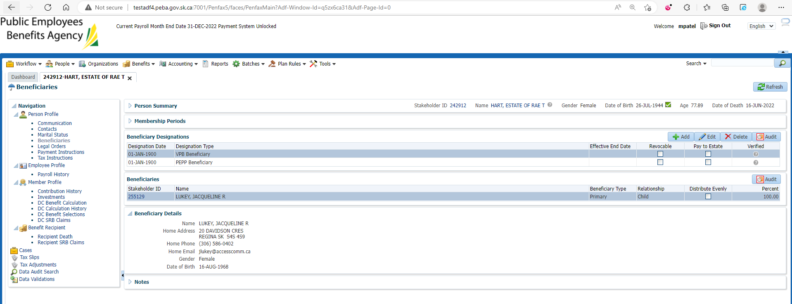

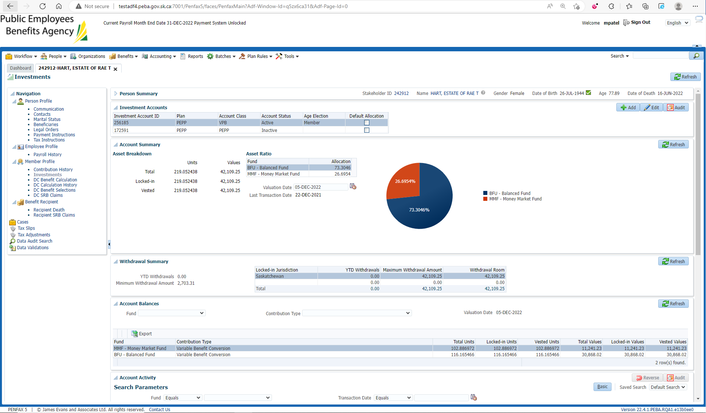

Go to DC Benefit Selection

Add DC Benefit Selection and next

Add allocations and Save

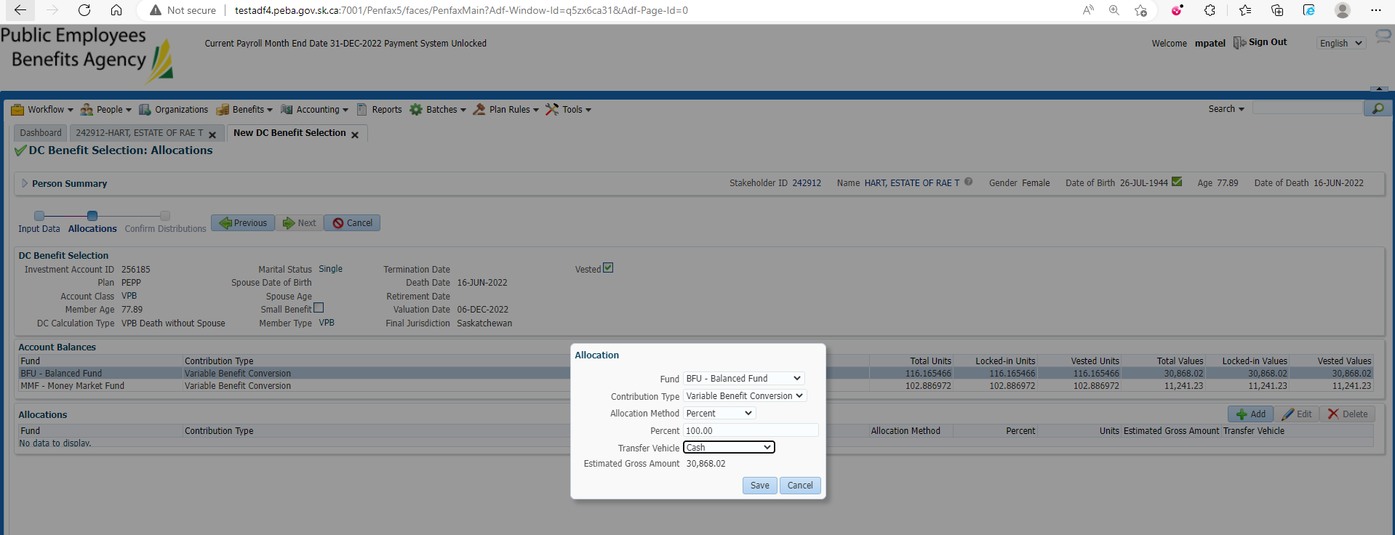

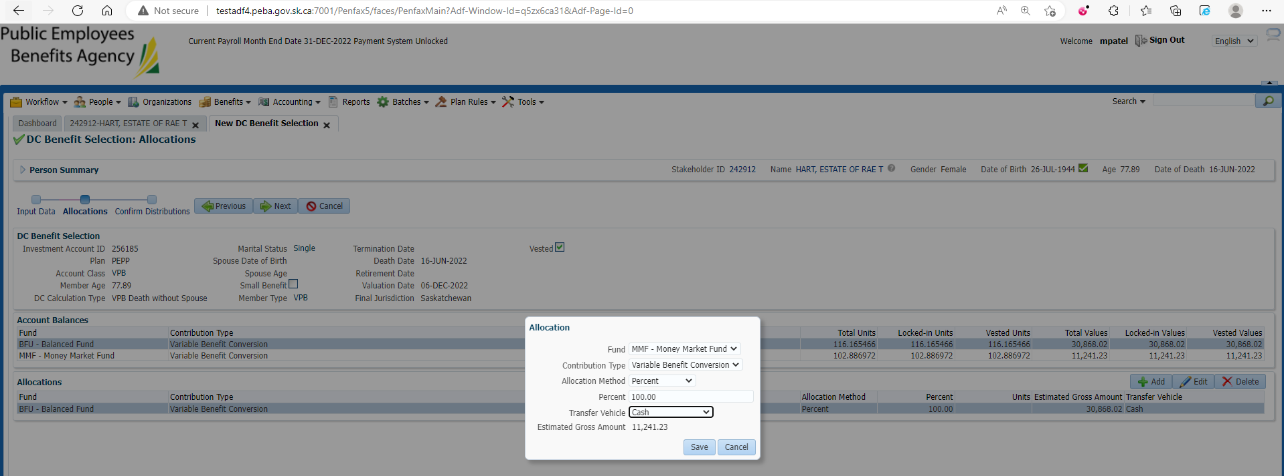

Next

Submit for Approval and Approve it

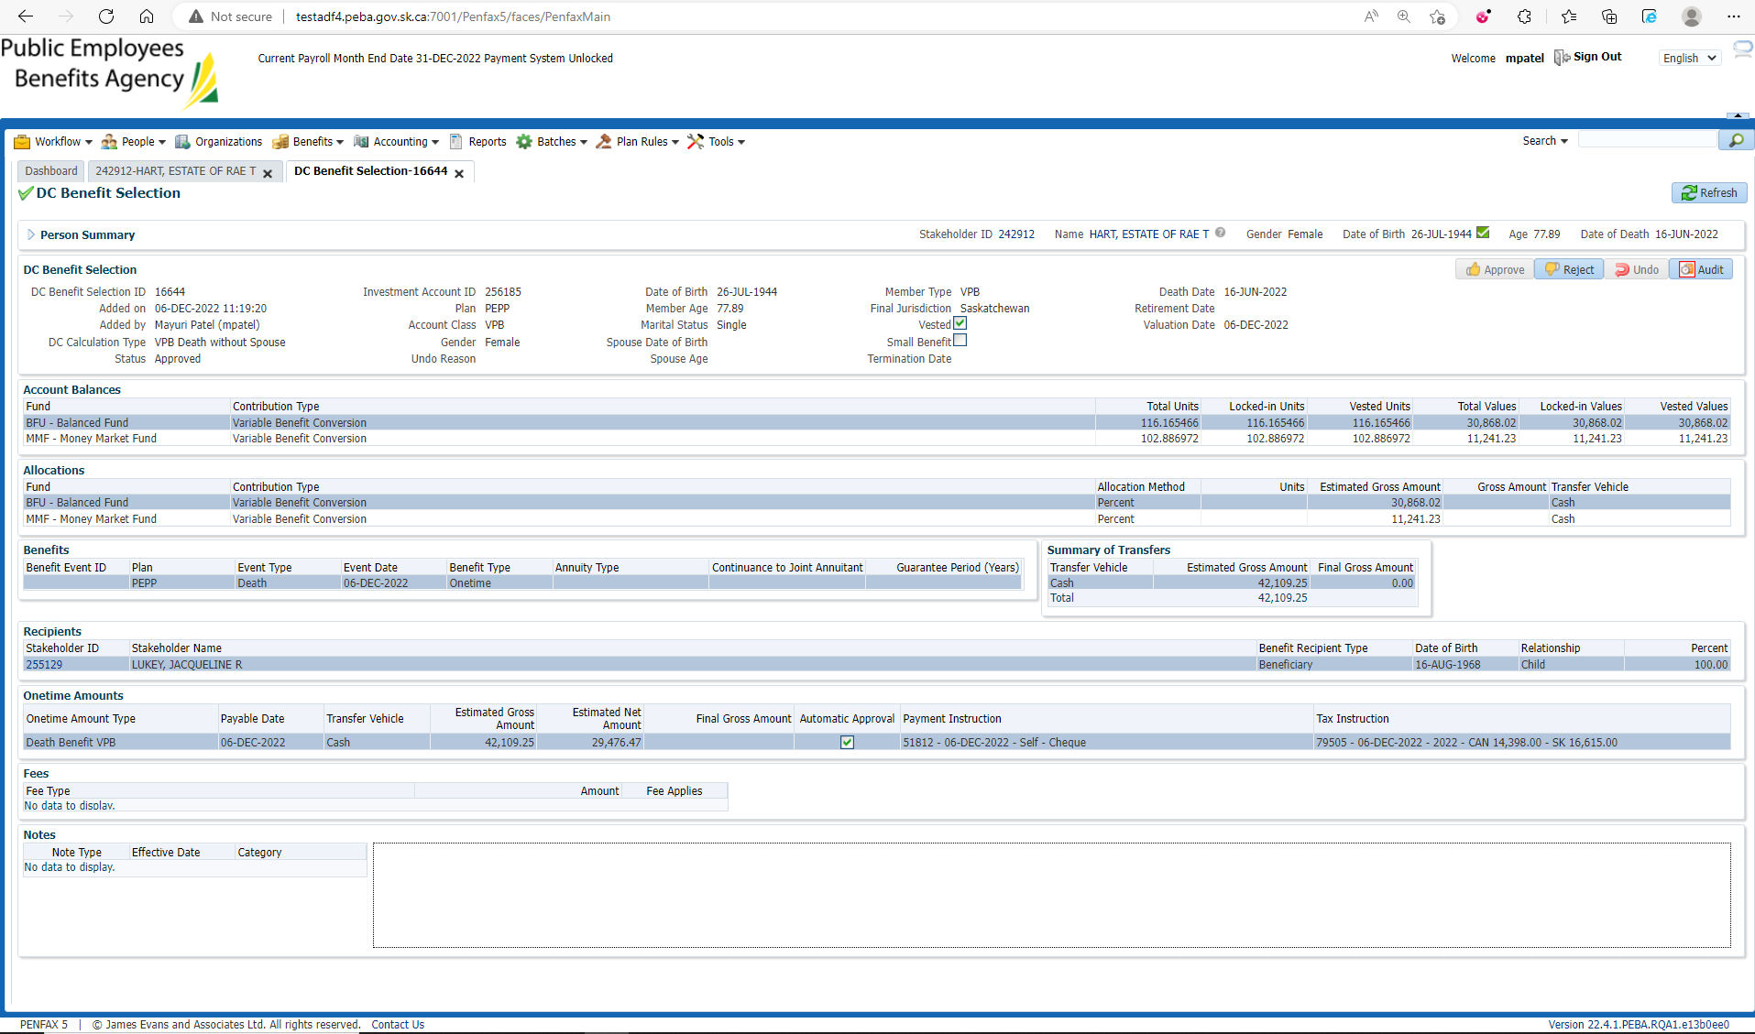

After Overnight PIT Batch

Open VPB beneficiary profile

Benefit Recipient🡪 Onetime Amount

Make sure Death Benefit VPB is processed

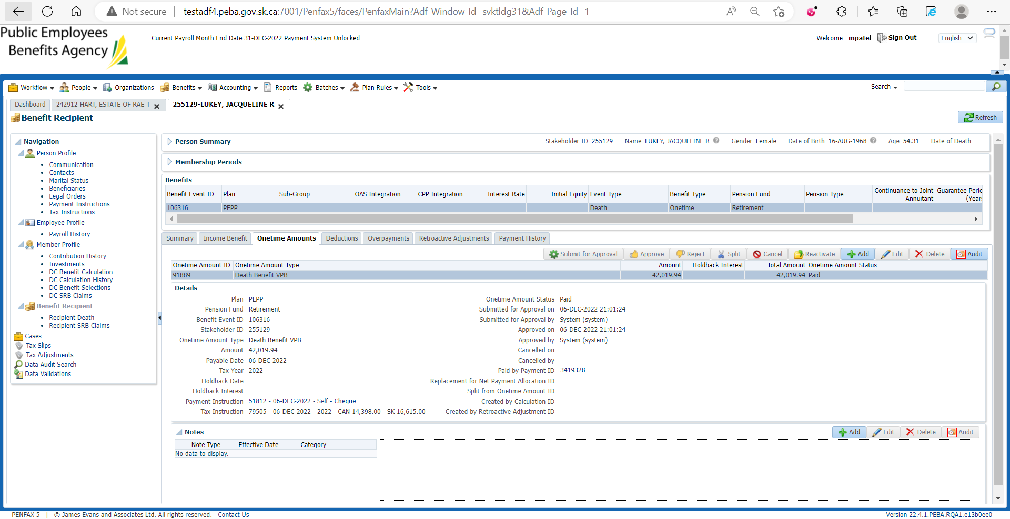

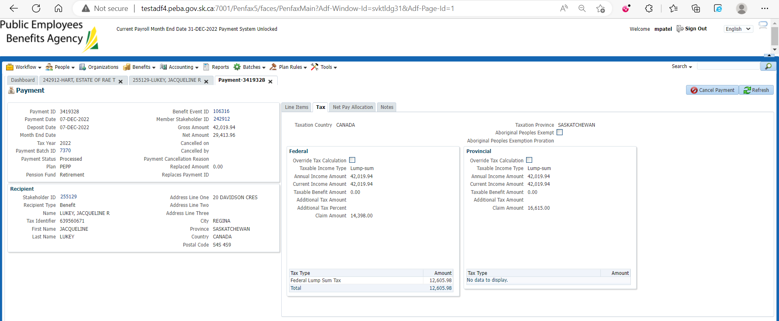

Check the Valuation Report. Go to Batches -> Batch Processes. Search with “PEPP Valuation Report” as Batch Process Type and open the very first record in the list (batch processed a day before).

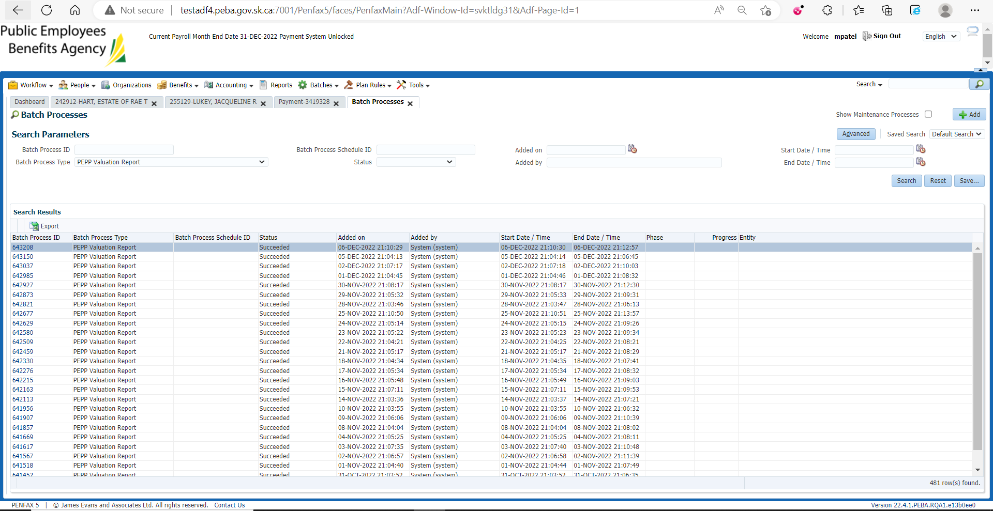

Go to Files tab and open VPB valuation excel

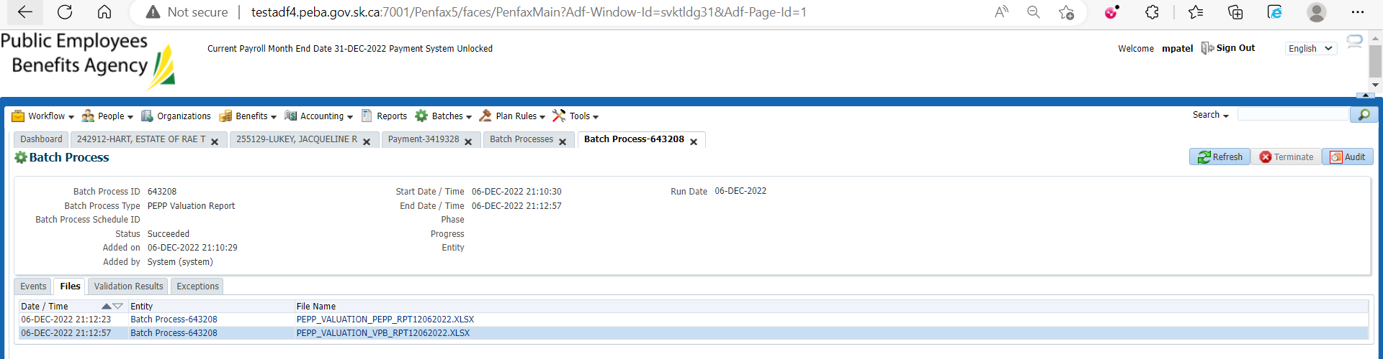

Section Seven

